Ideation Phase

Define the Problem Statements

|  |  |
| --- | --- |
| Date | 19 September 2022 |
| Project Name | Project – Web Phishing Detection |
| Maximum Marks | 2 Marks |
| Team ID | PNT2022TMID52729 |

# Web Phishing Problem Statement:



Common users who look for information on the web are unsafe on the internet who need a method to ensure the links they click are secure because scams are common and no one should become a victim of web phishing.

# Web Phishing Problem Statement Template:

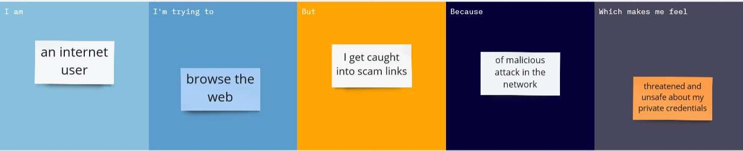

|  |  |  |  |  |  |
| --- | --- | --- | --- | --- | --- |
| **Problem**  **Statement (PS)** | **I am** | **I’m trying to** | **But** | **Because** | **Which makes me feel** |
| PS-1 | Internet user | Browse the internet | I identify a scam | An attacker masquerades as a reputable entity | Unsafe about my information that is shared over the  network |
| PS-2 | Enterprise user | Open emails in the cloud  server | I detect malicious  protocols | They are not cryptographically  signed | Emails are unverified and third party  intrusion |